Fundamentals of Programming

Name: Syed Asad Raza Zaidi

Section: ME-15A

Roll no: 464239

ASSIGNMENT 2

Task 1:

Task 2: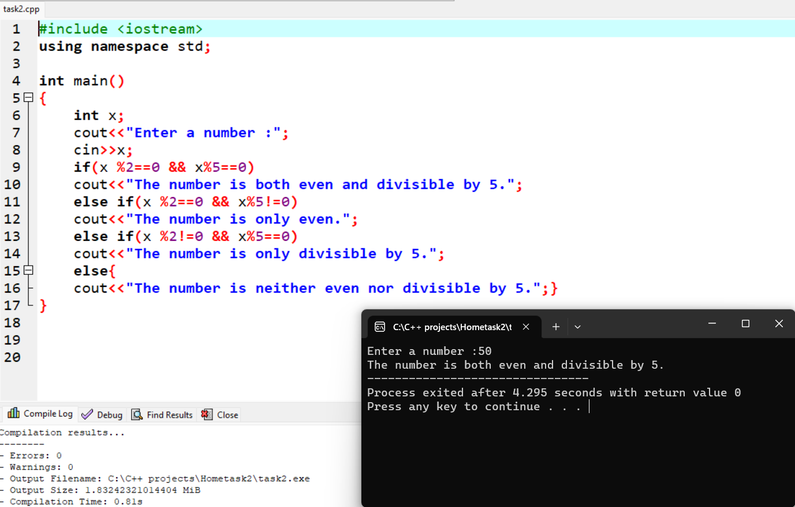

Task 4:

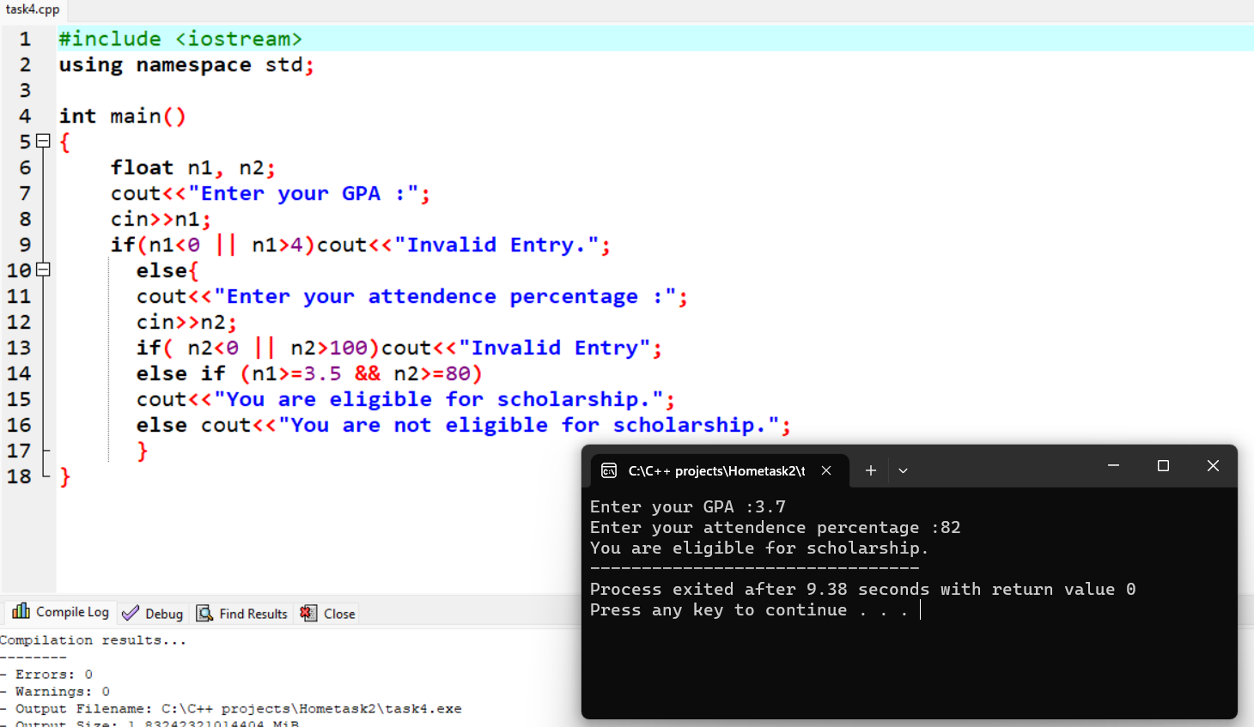

Task 5:

